**Chapter 5**

**Integration**

**5.2. The Definite Integral**

**Section Exercises**

**In the following exercises, express the limits as integrals.**

61.  over 

Answer: 

63.  over 

Answer: 

**In the following exercises, given *Ln* or *Rn* as indicated, express their limits as  as definite integrals, identifying the correct intervals**.

65. 

Answer: 

67. 

Answer: 

69. 

Answer: 

**In the following exercises, evaluate the integrals of the functions graphed using the formulas for areas of triangles and circles, and subtracting the areas below the *x*-axis.**

71.

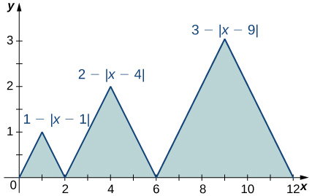

Answer: 

73.

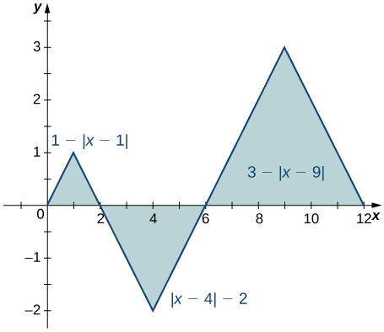

Answer: 

75.

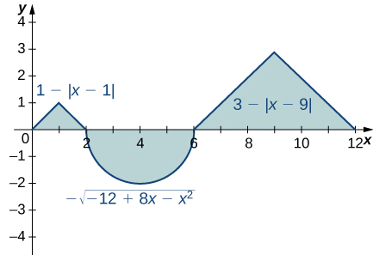

Answer: 

**In the following exercises, evaluate the integral using area formulas.**

77. 

Answer: The integral is the area of the triangle, 

79. 

Answer: The integral is the area of the triangle, 9.

81. 

Answer: The integral is the area .

83. 

Answer: The integral is the area of the “big” triangle less the “missing” triangle, 

**In the following exercises, use averages of values at the left (*L*) and right (*R*) endpoints to compute the integrals of the piecewise linear functions with graphs that pass through the given list of points over the indicated intervals.**

85.  over 

Answer: , , 

87.  over 

Answer: , , 

**Suppose that  and  and  and . In the following exercises, compute the integrals.**

89. 

Answer: 

91. 

Answer: 

93. 

Answer: 

**In the following exercises, use the identity  to compute the integrals.**

95. 

Answer: The integrand is odd; the integral is zero.

97.  (*Hint:* Look at the graph of *f*.)

Answer: The integrand is antisymmetric with respect to . The integral is zero.

**In the following exercises, given that ,  and , compute the integrals**.

99. 

Answer: 

101. 

Answer: 

103. 

Answer: 

**In the following exercises, use the comparison theorem**

105. Show that .

Answer: The integrand is negative over .

107. Show that .

Answer:  over , so over .

109. Show that .

Answer: . Multiply by the length of the interval to get the inequality.

**In the following exercises, find the average value *f*ave of *f* between *a* and *b*, and find a point *c*, where .**

111. , , 

Answer: ; 

113. , , 

Answer:  when 

115. , , 

Answer: ; 

**In the following exercises, approximate the average value using Riemann sums *L*100 and *R*100. How does your answer compare with the exact given answer?**

117. **[T]** over the interval ; the exact solution is .

Answer: , ; the exact average is between these values.

119. **[T]** over the interval ; the exact solution is .

Answer: , 

**In the following exercises, compute the average value using the left Riemann sums *LN* for. How does the accuracy compare with the given exact value?**

121. **[T]** over the interval ; the exact solution is .

Answer: , , . The exact answer , so *L*100 is not accurate.

123. **[T]**over the interval ; the exact solution is .

Answer: , , . The exact answer , so *L*100 is not accurate to first decimal.

125. Suppose that  and . Show that .

Answer: Use . Then, .

127. Show that the average value of  over  is equal to . Without further calculation, determine whether the average value of  over  is also equal to .

Answer:  so divide by the length 2*π* of the interval.  has period *π*, so yes, it is true.

129. Suppose that parabola  opens downward () and has a vertex of . For which interval  is  as large as possible?

Answer: The integral is maximized when one uses the largest interval on which *p* is nonnegative. Thus,  and .

131. Suppose *f* and *g* are continuous functions such that  for every subinterval  of . Explain why  for all values of *x*.

Answer: If  for some , then since  is continuous, there is an interval containing *t*0 such that  over the interval , and then  over this interval.

133. Suppose that  can be partitioned. taking  such that the average value of *f* over each subinterval  is equal to 1 for each  Explain why the average value of *f* over  is also equal to 1.

Answer: The integral of *f* over an interval is the same as the integral of the average of *f* over that interval. Thus, 

Dividing through by  gives the desired identity.

135. Suppose that for each *i* such that  one has . Show that .

Answer: 

137. **[T]** Compute the left and right Riemann sums, *L*10 and *R*10, and their average  for  over . Given that , to how many decimal places is  accurate?

Answer: , ,  so the estimate is accurate to two decimal places.

139. Estimate  using the left and right endpoint sums, each with a single rectangle. How does the average of these left and right endpoint sums compare with the actual value ?

Answer: The average is , which is equal to the integral in this case.

141. From the graph of  shown:

* 1. Explain why .
  2. Explain why, in general,  for any value of *a*.

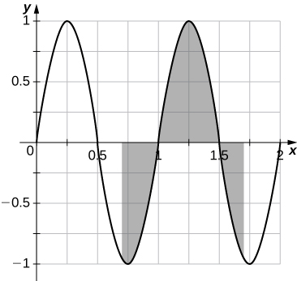

Answer: a. The graph is antisymmetric with respect to  over  so the average value is zero. b. For any value of *a*, the graph between  is a shift of the graph over , so the net areas above and below the axis do not change and the average remains zero.

143. If *f* is 1-periodic and , is it necessarily true that  for all *A*?

Answer: Yes, the integral over any interval of length 1 is the same.

This file is copyright 2016, Rice University. All Rights Reserved.